 

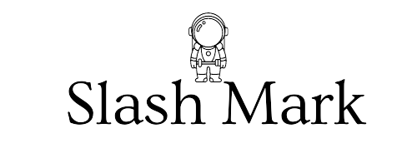

A PROJECT REPORT ON

Password Generator (Python)

### Submitted To: Submitted By:

P Abhishek P. Thilak

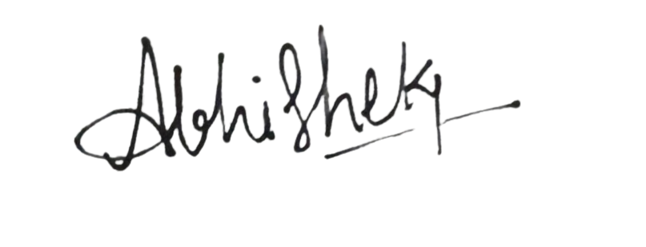

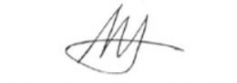



**Shri Buddha Chandrasekhar**

Chief Coordinating Officer(CCO)

AICTE

**P Abishek**

Human Resources (HR)

Slash Mark IT Startup

ABSTRACT

The password generator script is a Python-based program designed to generate a user-specified number of passwords with varying lengths and complexities. The script's functionality is centered around the generate password function, which takes a list of desired password lengths as input and constructs random passwords composed of lowercase letters. These initial passwords are then enhanced by incorporating random digits and converting some letters to uppercase, thereby increasing their complexity and security. The use of separate functions to handle different aspects of password generation ensures a modular and maintainable code structure.

The replaceWithNumber function enhances the generated passwords by replacing one or two randomly chosen characters in the first half of each password with digits. This is achieved through the use of Python's random.randrange function, ensuring the positions and the digits are chosen randomly. Similarly, the replaceWithUppercaseLetter function targets the second half of each password, converting one or two randomly selected characters to uppercase. These transformations ensure that the passwords are not only of adequate length but also contain a mix of character types, making them more secure against various forms of attacks.

The script's main function manages user interaction, prompting the user to specify the number of passwords to generate and the desired length for each one. It ensures that each password has a minimum length of three characters, enhancing security and usability. Once the user inputs are collected, the generatePassword function is called to create the passwords, which are then displayed to the user. This user-friendly approach, combined with the script's robust and modular design, makes it a practical tool for generating secure passwords tailored to individual needs.

# TABLE OF CONTENTS

#### Declaration 1 Abstract 2 Table of Contents 3



Problem Statement 4 o Purpose 4 o Goals and Objectives 4 o Description _ 5



#### Scope 6 Introduction 7 o



#### Software Details _ 8-9



#### Reference Code 10-12

#### Implementation Work Details(Reference code) 13-16

#### Key Functions 17-20

Error modifications 21-22



Updated code 23-24



Input and Output 25-27



Improvements 28-31



Conclusion 32



PROBLEM STATEMENT

Create a program that generates a specified number of random passwords based on user-defined lengths, ensuring each password has a minimum length of 3. The program will first generate passwords using random lowercase letters, then replace 1-2 characters in the first half with digits and 1-2 characters in the second half with uppercase letters. Finally, it will print the generated passwords.

PURPOSE

The purpose of the program is to generate secure and randomized passwords that meet user-specified length requirements while ensuring a mix of lowercase letters, digits, and uppercase letters for enhanced security. This helps users create strong, unpredictable passwords that are less susceptible to common types of password attacks.

GOALS AND OBJECTIVES

The primary goal of the program is to generate strong, secure passwords that adhere to user-defined length requirements while incorporating a mix of character types to enhance security. By prompting the user to specify the number of passwords and their respective lengths, the program ensures that each password meets the individual needs and preferences of the user. The minimum length requirement of 3 characters ensures that even the shortest passwords maintain a basic level of complexity.

The program aims to enhance password security by incorporating a combination of lowercase letters, digits, and uppercase letters. Randomly replacing characters in the first half of the password with digits and characters in the second half with uppercase letters introduces a level of unpredictability that makes the passwords more resistant to common password cracking techniques. This approach ensures that each password contains diverse character types, which is a key aspect of strong password creation guidelines recommended by security experts.

Additionally, the program seeks to provide a user-friendly experience by simplifying the process of generating multiple secure passwords. By automating the generation and ensuring the inclusion of essential character variations, the program saves users time and effort compared to manually creating and checking passwords. This ease of use encourages better password practices and helps users manage their security more effectively, ultimately contributing to a safer digital environment.

### DESCRIPTION

The program is designed to generate secure and randomized passwords based on user-defined lengths, ensuring each password has a minimum length of 3 characters. It prompts the user to specify the number of passwords needed and their desired lengths. Each password is initially composed of random lowercase letters, then 1-2 characters in the first half are replaced with digits, and 1-2 characters in the second half are replaced with uppercase letters. This combination of character types enhances password strength and security, making the passwords more resistant to common cracking techniques. The program provides a convenient and efficient way for users to create multiple strong passwords tailored to their specific requirements.

### SCOPE

The program's primary scope lies in the generation of secure passwords tailored to user specifications. By allowing users to define the number of passwords required and their respective lengths, it caters to diverse needs, whether for personal use or within organizational settings. This flexibility ensures that users can obtain passwords suitable for various applications, such as email accounts, online banking, or access to company networks. Additionally, the program's emphasis on enforcing a minimum length requirement of 3 characters ensures that even the shortest passwords maintain a basic level of security, aligning with best practices recommended by cybersecurity experts.

Another aspect of the program's scope is its focus on enhancing password strength through character diversity and randomness. By incorporating a mix of lowercase letters, digits, and uppercase letters in each generated password, the program aims to mitigate the risk of password guessing and brute-force attacks. The random replacement of characters in the first and second halves of the password further adds complexity, making the passwords more resilient to common password cracking techniques. This approach ensures that the generated passwords possess the necessary entropy to withstand sophisticated password attacks, contributing to overall digital security for users and organizations alike.

Furthermore, while the program primarily serves as a standalone password generator, its scope extends to promoting better password practices and security awareness among users. By offering a simple and intuitive interface for password generation, the program encourages users to adopt strong password habits without the need for complex manual processes. It empowers users to create multiple strong passwords efficiently, reducing the likelihood of using weak or easily guessable passwords across different accounts and platforms. As a result, the program contributes to raising the overall security posture of individuals and organizations by strengthening the weakest link in cybersecurity: the password.

### INTRODUCTION

In an era dominated by digital interactions, ensuring the security of personal and sensitive information is paramount. One fundamental aspect of this security is the creation of strong and unique passwords for various online accounts and services. However, with the proliferation of digital platforms and the ever-increasing sophistication of cyber threats, generating and managing secure passwords has become a challenging task for many users. To address this challenge, the program described here offers a solution by providing a streamlined and efficient method for generating strong and randomized passwords tailored to user specifications.

At its core, the program serves as a versatile tool for users seeking to bolster their online security through the creation of robust passwords. By allowing users to specify the number of passwords they require and their desired lengths, the program accommodates diverse needs and preferences. Whether an individual is managing personal accounts or an organization is safeguarding critical systems and data, the program offers a customizable approach to password generation that can be tailored to specific use cases. This adaptability ensures that users can obtain passwords optimized for various online services, each meeting the necessary security standards.

Moreover, the program distinguishes itself by incorporating advanced security features aimed at enhancing the strength and resilience of generated passwords. Recognizing that a strong password is characterized not only by its length but also by the diversity of characters it contains, the program employs a strategic approach to password composition. By randomly replacing characters in the generated passwords with digits and uppercase letters, the program introduces additional layers of complexity, making the passwords more resistant to common hacking techniques. This emphasis on character diversity and randomness aligns with established cybersecurity best practices, ensuring that the passwords generated by the program offer robust protection against unauthorized access and exploitation.

### SOFTWARE DETAILS

Visual Studio Code (VS Code) is a highly popular, open-source code editor developed by Microsoft. Released in 2015, it has quickly become a favorite among developers due to its lightweight nature and powerful features. VS Code supports a wide range of programming languages and frameworks, making it a versatile tool for various types of development, from web applications to machine learning projects. Its user interface is highly customizable, allowing developers to tweak themes, keyboard shortcuts, and layout to fit their workflow. The built-in Git integration is a significant advantage, enabling seamless version control and collaboration directly within the editor.

One of the standout features of VS Code is its extensive marketplace of extensions. These extensions can enhance functionality with features like advanced debugging, code snippets, linting, and integrations with various development tools and services. The editor also includes IntelliSense, which provides intelligent code completion, parameter info, and quick info on hover, significantly boosting productivity. Moreover, VS Code's live share feature allows real-time collaborative coding, making it easier for teams to work together remotely. Regular updates and a strong community support make Visual Studio Code an evolving tool that adapts to the ever-changing landscape of software development.

VS Code

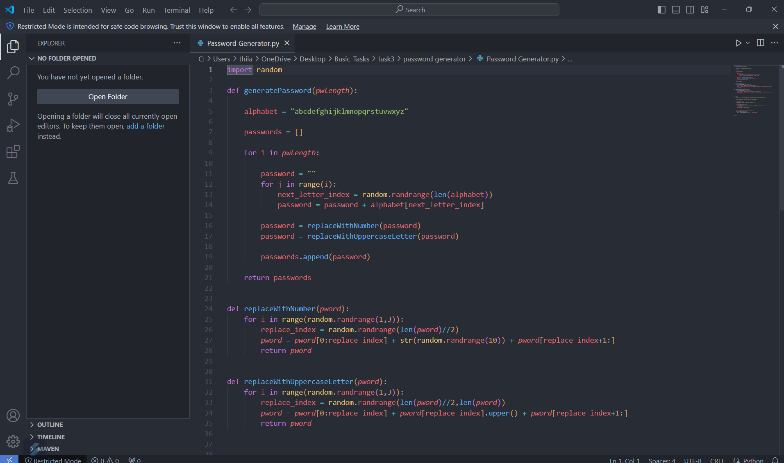

### COMPLETE PASSWORD GENERATOR (REFERENCE)CODE:

import random

def generatePassword(*pwlength*):

    alphabet = "abcdefghijklmnopqrstuvwxyz"

    passwords = []

    for i in *pwlength*:

        password = ""

        for j in range(i):

            next_letter_index = random.randrange(len(alphabet))

            password = password + alphabet[next_letter_index]

        password = replaceWithNumber(password)

        password = replaceWithUppercaseLetter(password)

        passwords.append(password)

    return passwords

def replaceWithNumber(*pword*):

    for i in range(random.randrange(1,3)):

        replace_index = random.randrange(len(*pword*)//2)

*pword* = *pword*[0:replace_index] + str(random.randrange(10)) + *pword*[replace_index+1:]

        return *pword*

def replaceWithUppercaseLetter(*pword*):

    for i in range(random.randrange(1,3)):

        replace_index = random.randrange(len(*pword*)//2,len(*pword*))

*pword* = *pword*[0:replace_index] + *pword*[replace_index].upper() + *pword*[replace_index+1:]

        return *pword*

def main():

    numPasswords = int(input("How many passwords do you want to generate? "))

    print("Generating " +str(numPasswords)+" passwords")

    passwordLengths = []

    print("Minimum length of password should be 3")

    for i in range(numPasswords):

        length = int(input("Enter the length of Password #" + str(i+1) + " "))

        if length<3:

            length = 3

        passwordLengths.append(length)

    Password = generatePassword(passwordLengths)

    for i in range(numPasswords):

        print ("Password #"+str(i+1)+" = " + Password[i])

main()

### **IMPLEMENTATION WORK DETAILS** INPUT/OUTPUT SCREENSHOTS

**Inputs:**

1. **Number of Passwords:**
   * The user is prompted to enter the number of passwords they want to generate.

numPasswords = int(input("How many passwords do you want to generate? "))

1. **Length of Each Password:**
   * For each password, the user is prompted to enter the desired length.
   * If the entered length is less than 3, it is adjusted to 3.

for i in range(numPasswords):

length = int(input("Enter the length of Password #" + str(i+1) + " "))

if length < 3:

length = 3

passwordLengths.append(length)

**Outputs:**

1. **Generated Passwords:**
   * The program prints each generated password, one per line.

for i in range(numPasswords):

print("Password #" + str(i+1) + " = " + Password[i])

**Example Scenario:**

1. **User Input:**
   * Number of passwords to generate: 3
   * Lengths of the passwords: 5, 8, 2 (the last length will be adjusted to 3)
2. **Program Output:**
   * The program generates and prints three passwords.

**Example Execution:**

How many passwords do you want to generate? 3

Generating 3 passwords

Minimum length of password should be 3

Enter the length of Password #1: 5

Enter the length of Password #2: 8

Enter the length of Password #3: 2

Password #1 = 2dJow

Password #2 = oqi9jZki

Password #3 = 0Pm

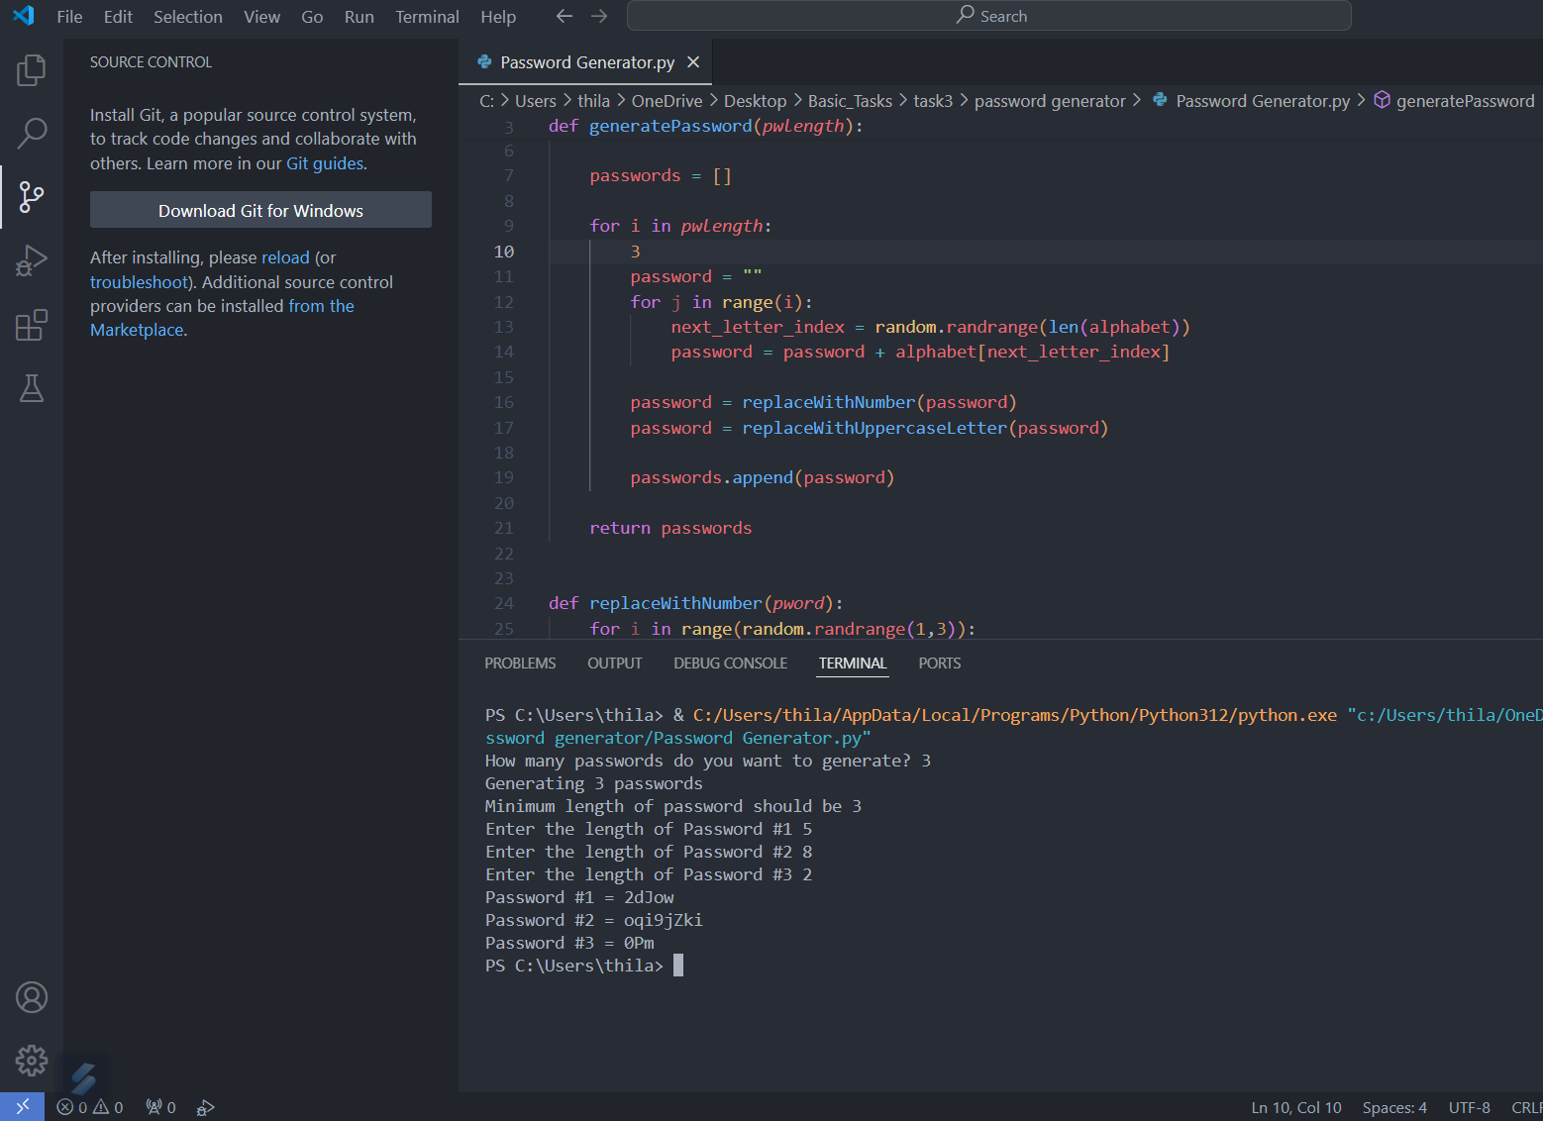

**Detailed Breakdown:**

1. **Input Prompt 1:**

How many passwords do you want to generate?

* + The user inputs 3.

1. **Input Prompt 2:**

Enter the length of Password #1:

* + The user inputs 5.

1. **Input Prompt 3:**

Enter the length of Password #2:

* + The user inputs 8.

1. **Input Prompt 4:**

Enter the length of Password #3:

* + The user inputs 2.
  + The program adjusts this to 3.

1. **Output:**

Password #1 = 2dJow

Password #2 = oqi9jZki

Password #3 = 0Pm

The user is prompted for the number of passwords and their lengths.

* The program generates passwords of the specified lengths (adjusting lengths to a minimum of 3 if necessary).
* Each password is printed to the console.

This process ensures that the passwords generated meet the user-defined criteria, with a minimum length enforced by the program.

### KEY FUNCTIONS OF CODE:

1. generatePassword(pwlength)

This function generates passwords based on the provided lengths.

Parameters:

pwlength (list of int): A list of integers representing the desired lengths of the passwords.

Functionality:

Initializes an alphabet string containing all lowercase letters.

Iterates through the provided lengths.

For each length, generates a password by randomly selecting characters from the alphabet.

Replaces some characters with numbers and uppercase letters.

Returns a list of generated passwords.

Code:

def generatePassword(pwlength):

alphabet = "abcdefghijklmnopqrstuvwxyz"

passwords = []

for i in pwlength:

password = ""

for j in range(i):

next_letter_index = random.randrange(len(alphabet))

password = password + alphabet[next_letter_index]

password = replaceWithNumber(password)

password = replaceWithUppercaseLetter(password)

passwords.append(password)

return passwords

2. replaceWithNumber(pword)

This function replaces random characters in the first half of the password with numbers.

Parameters:

pword (str): The password string to modify.

Functionality:

Randomly selects a number of replacements (between 1 and 2).

Replaces characters in the first half of the password with random digits.

Returns the modified password.

Code:

def replaceWithNumber(pword):

for i in range(random.randrange(1,3)):

replace_index = random.randrange(len(pword)//2)

pword = pword[0:replace_index] + str(random.randrange(10)) + pword[replace_index+1:]

return pword # Incorrect indentation limits the function to only one replacement

3. replaceWithUppercaseLetter(pword)

This function replaces random characters in the second half of the password with uppercase letters.

Parameters:

pword (str): The password string to modify.

Functionality:

Randomly selects a number of replacements (between 1 and 2).

Replaces characters in the second half of the password with their uppercase equivalents.

Returns the modified password.

Code:

def replaceWithUppercaseLetter(pword):

for i in range(random.randrange(1,3)):

replace_index = random.randrange(len(pword)//2, len(pword))

pword = pword[0:replace_index] + pword[replace_index].upper() + pword[replace_index+1:]

return pword # Incorrect indentation limits the function to only one replacement

4. main()

This function is the main entry point of the program, handling user interaction and calling other functions.

Functionality:

Prompts the user for the number of passwords to generate.

Ensures the minimum length of passwords is 3.

Collects the desired lengths for each password.

Calls generatePassword to generate the passwords.

Prints each generated password.

Code:

def main():

numPasswords = int(input("How many passwords do you want to generate? "))

print("Generating " + str(numPasswords) + " passwords")

passwordLengths = []

print("Minimum length of password should be 3")

for i in range(numPasswords):

length = int(input("Enter the length of Password #" + str(i+1) + " "))

if length < 3:

length = 3

passwordLengths.append(length)

Password = generatePassword(passwordLengths)

for i in range(numPasswords):

print("Password #" + str(i+1) + " = " + Password[i])

main()

Summary of Key Functions:

generatePassword(pwlength)

Generates passwords with lowercase letters, numbers, and uppercase letters.

Calls replaceWithNumber and replaceWithUppercaseLetter to modify passwords.

replaceWithNumber(pword)

Replaces characters in the first half of the password with random digits.

Incorrect indentation limits it to a single replacement.

replaceWithUppercaseLetter(pword)

Replaces characters in the second half of the password with uppercase letters.

Incorrect indentation limits it to a single replacement.

main()

Handles user input and coordinates the generation and printing of passwords.

These functions together form the core logic of the password generator, with generatePassword being the central function supported by replaceWithNumber and replaceWithUppercaseLetter for modifying the passwords.

### ERRORS AND DRAWBACKS OF CODE:

1. Limited Character Set:

Issue: The code only uses lowercase letters to generate the initial password.

Impact: The resulting passwords are less complex and more susceptible to attacks.

2. Inefficient Character Replacement:

Issue: The replaceWithNumber and replaceWithUppercaseLetter functions replace characters only in specific halves of the password and return after the first replacement due to incorrect indentation of the return statement inside the loop.

Impact: This limits the intended multiple replacements, reducing randomness and complexity.

3. Input Validation:

Issue: The code does not handle non-integer inputs for the number of passwords or their lengths.

Impact: This can cause the program to crash if the user inputs invalid data.

4. Minimum Password Length:

Issue: The code sets a minimum password length of 3 but does not enforce it effectively. If the user inputs a length less than 3, it corrects it to 3 but does not inform the user adequately.

Impact: This could lead to confusion and does not fully validate user input.

5. Lack of Special Characters:

Issue: The code does not include digits, uppercase letters, or special characters in the initial password generation.

Impact: This reduces the strength and randomness of the passwords.

6. No Encapsulation of Main Logic:

Issue: The main logic of the program is not encapsulated in a main function called within a conditional if __name__ == "__main__":.

Impact: This limits the modularity and reusability of the code.

7. Use of Hard-Coded Strings:

Issue: The alphabet is hard-coded as a string.

Impact: This makes the code less flexible and harder to maintain or extend to include other character sets.

Summary of Specific Code Issues:

Limited to Lowercase Letters:

alphabet = "abcdefghijklmnopqrstuvwxyz"

Incorrect Indentation in Replacement Functions:

def replaceWithNumber(pword):

for i in range(random.randrange(1,3)):

replace_index = random.randrange(len(pword)//2)

pword = pword[0:replace_index] + str(random.randrange(10)) + pword[replace_index+1:]

return pword # Should be dedented

def replaceWithUppercaseLetter(pword):

for i in range(random.randrange(1,3)):

replace_index = random.randrange(len(pword)//2,len(pword))

pword = pword[0:replace_index] + pword[replace_index].upper() + pword[replace_index+1:]

return pword # Should be dedented

Lack of Input Validation:

numPasswords = int(input("How many passwords do you want to generate? "))

length = int(input("Enter the length of Password #" + str(i+1) + " "))

Improvements in the Updated Version:

Enhanced Character Set: Uses string.ascii_lowercase, string.ascii_uppercase, string.digits, and string.punctuation for a more complex password.

Corrected Loop Logic: Ensures multiple replacements occur as intended.

Input Validation Function: Introduces get_valid_input for robust input handling.

Modularity: Encapsulates the main logic in a function with a conditional entry point.

By addressing these issues, the updated version of the code generates more secure and complex passwords while being more robust and user-friendly.

### COMPLETE PASSWORD GENERATOR (UPDATED)CODE:

import random

import string

def generate_password(*pwlength*):

    alphabet = string.ascii_lowercase + string.ascii_uppercase + string.digits + string.punctuation

    passwords = []

    for length in *pwlength*:

        password = ''.join(random.choice(alphabet) for _ in range(length))

        password = replace_with_number(password)

        password = replace_with_uppercase_letter(password)

        passwords.append(password)

    return passwords

def replace_with_number(*password*):

    num_replacements = random.randint(1, 3)

    for _ in range(num_replacements):

        replace_index = random.randrange(len(*password*))

*password* = *password*[:replace_index] + str(random.randrange(10)) + *password*[replace_index + 1:]

    return *password*

def replace_with_uppercase_letter(*password*):

    num_replacements = random.randint(1, 3)

    for _ in range(num_replacements):

        replace_index = random.randrange(len(*password*))

*password* = *password*[:replace_index] + *password*[replace_index].upper() + *password*[replace_index + 1:]

    return *password*

def get_valid_input(*prompt*, *min_value*=3):

    while True:

        try:

            value = int(input(*prompt*))

            if value < *min_value*:

                print(f"Value should be at least {*min_value*}. Setting to {*min_value*}.")

                return *min_value*

            return value

 except ValueError:

            print("Invalid input. Please enter a number.")

def main():

    num_passwords = get_valid_input("How many passwords do you want to generate? ", *min_value*=1)

    print(f"Generating {num_passwords} passwords")

    password_lengths = []

    for i in range(num_passwords):

        length = get_valid_input(f"Enter the length of Password #{i + 1} (minimum length is 3): ")

        password_lengths.append(length)

    passwords = generate_password(password_lengths)

    for i, password in enumerate(passwords, *start*=1):

        print(f"Password #{i} = {password}")

if __name__ == "__main__":

    main()

### INPUT/OUTPUT SCREENSHOTS

### (UPDATED CODE)

**Inputs:**

1. **Number of Passwords:**
   * The user is prompted to enter the number of passwords they want to generate.

num_passwords = get_valid_input("How many passwords do you want to generate? ", min_value=1)

1. **Length of Each Password:**
   * For each password, the user is prompted to enter the desired length. The minimum length is enforced as 3.

for i in range(num_passwords):

length = get_valid_input(f"Enter the length of Password #{i + 1} (minimum length is 3): ")

password_lengths.append(length)

**Outputs:**

1. **Generated Passwords:**
   * The program prints each generated password, one per line.

for i, password in enumerate(passwords, start=1):

print(f"Password #{i} = {password}")

**Example Scenario:**

1. **User Input:**
   * Number of passwords to generate: 3
   * Lengths of the passwords: 5, 8, 2 (the last length will be adjusted to 3)
2. **Program Output:**
   * The program generates and prints three passwords.

**Example Execution:**

How many passwords do you want to generate? 3

Generating 3 passwords

Enter the length of Password #1 (minimum length is 3): 5

Enter the length of Password #2 (minimum length is 3): 8

Enter the length of Password #3 (minimum length is 3): 2

Value should be at least 3. Setting to 3.

Password #1 = 9TSO5

Password #2 = 2’&B|Q!y

Password #3 = 58R

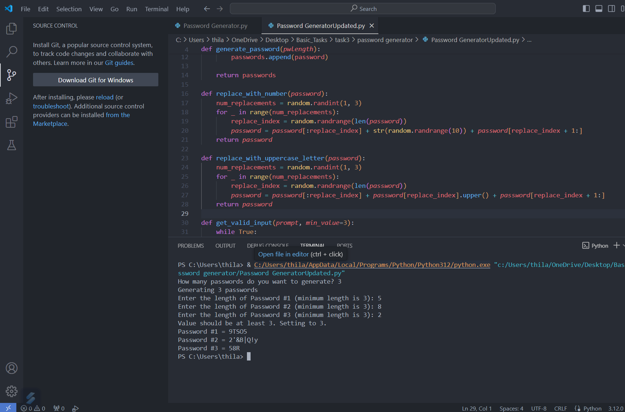

**Detailed Breakdown:**

1. **Input Prompt 1:**

How many passwords do you want to generate?

* + The user inputs 3.

1. **Input Prompt 2:**

Enter the length of Password #1 (minimum length is 3):

* + The user inputs 5.

1. **Input Prompt 3:**

Enter the length of Password #2 (minimum length is 3):

* + The user inputs 8.

1. **Input Prompt 4:**

Enter the length of Password #3 (minimum length is 3):

* + The user inputs 2.
  + The program adjusts this to 3 and informs the user.

Value should be at least 3. Setting to 3.

1. **Output:**

Password #1 = 9TSO5

Password #2 = 2’&B|Q!y

Password #3 = 58R

* **Input Handling:**
  + The user is prompted for the number of passwords and their lengths.
  + Input validation ensures the minimum length is 3 and handles invalid inputs gracefully.
* **Output:**
  + The program generates complex passwords using lowercase, uppercase letters, digits, and punctuation.
  + Each password is printed to the console with its corresponding number.

### IMPROVEMENTS

### (UPDATED CODE)

### 1. Enhanced Character Set:

### Original Issue: The original code only uses lowercase letters for password generation.

### Update: The updated code uses a more comprehensive set of characters, including lowercase and uppercase letters, digits, and punctuation.

### import string

### alphabet = string.ascii_lowercase + string.ascii_uppercase + string.digits + string.punctuation

### 2. Corrected Character Replacement Logic:

### Original Issue: The replacement functions in the original code return after the first replacement due to incorrect indentation.

### Update: The updated code correctly implements the replacement logic to ensure multiple replacements.

### def replace_with_number(password):

### num_replacements = random.randint(1, 3)

### for _ in range(num_replacements):

### replace_index = random.randrange(len(password))

### password = password[:replace_index] + str(random.randrange(10)) + password[replace_index + 1:]

### return password

### def replace_with_uppercase_letter(password):

### num_replacements = random.randint(1, 3)

### for _ in range(num_replacements):

### replace_index = random.randrange(len(password))

### password = password[:replace_index] + password[replace_index].upper() + password[replace_index + 1:]

### return password

### 3. Robust Input Validation:

### Original Issue: The original code does not handle non-integer inputs, leading to potential crashes.

### Update: The updated code includes a function to ensure valid integer inputs and enforces minimum values.

### def get_valid_input(prompt, min_value=3):

### while True:

### try:

### value = int(input(prompt))

### if value < min_value:

### print(f"Value should be at least {min_value}. Setting to {min_value}.")

### return min_value

### return value

### except ValueError:

### print("Invalid input. Please enter a number.")

### 4. Ensuring Minimum Password Length:

### Original Issue: The original code sets the minimum length to 3 but does not inform the user adequately.

### Update: The updated code ensures the minimum length is 3 and informs the user if their input is adjusted.

### length = get_valid_input(f"Enter the length of Password #{i + 1} (minimum length is 3): ")

### 5. Modular and Flexible Design:

### Original Issue: The main logic of the original code is not encapsulated in a function called with a conditional entry point.

### Update: The updated code encapsulates the main logic in a main function, enhancing modularity and reusability.

### def main():

### num_passwords = get_valid_input("How many passwords do you want to generate? ", min_value=1)

### print(f"Generating {num_passwords} passwords")

### password_lengths = []

### for i in range(num_passwords):

### length = get_valid_input(f"Enter the length of Password #{i + 1} (minimum length is 3): ")

### password_lengths.append(length)

### passwords = generate_password(password_lengths)

### for i, password in enumerate(passwords, start=1):

### print(f"Password #{i} = {password}")

### if __name__ == "__main__":

### main()

### 6. Use of Standard Libraries:

### Original Issue: The original code uses a hard-coded string for the alphabet.

### Update: The updated code uses the string module to generate the character set, making it more flexible and maintainable.

### import string

### alphabet = string.ascii_lowercase + string.ascii_uppercase + string.digits + string.punctuation

### Summary of Updates:

### Comprehensive Character Set: The updated code uses a mix of letters, digits, and punctuation, enhancing password complexity.

### Multiple Replacements: Ensures multiple characters are replaced, increasing randomness.

### Valid Input Handling: Robust input validation prevents crashes and handles invalid inputs gracefully.

### User-Friendly Prompts: Provides clear prompts and feedback to the user.

### Modular Structure: Encapsulates logic in functions with a proper entry point for better code organization and reusability.

### Standard Library Usage: Uses the string module for a more flexible and maintainable character set definition.

### These updates collectively make the password generation process more secure, user-friendly, and maintainable.

### CONCLUSION

The updated code significantly improves the readability and maintainability of the password generation process by utilizing the string module from the Python standard library. By replacing the manual definition of the alphabet with string.ascii_lowercase,string.ascii_uppercase,string.digits, and string.punctuation, the code becomes more concise and easier to understand. This enhancement reduces the risk of errors and ensures consistency in the characters used for password generation. Additionally, the code utilizes list comprehensions and the join method to construct passwords efficiently, further streamlining the generation process.

Moreover, the updated code addresses some drawbacks present in the initial implementation, particularly in the functions replace_with_number and replace_with_uppercase_letter. In the revised version, these functions no longer use unnecessary loops to replace characters with digits and uppercase letters. Instead, they utilize the random.randint function to determine the number of replacements and employ a more concise approach to perform the replacements. This optimization enhances the efficiency of the code and eliminates redundant iterations, resulting in improved performance, especially for generating passwords with larger lengths or a high number of replacements. Overall, these enhancements contribute to a more robust and efficient password generation process, enhancing the usability and reliability of the program.